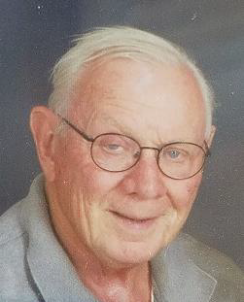

A NOTE ABOUT DR. ROBERT R. HODGES
Professor of English, 1928 – 2020
Professor Robert R. Hodges joined the faculty of the CSUF English Department in 1965, when the University, still in its first decade, was known as California State College, Fullerton. He was an important contributor during these early years to the development of the undergraduate and graduate curriculum in English. Many of the courses that focus on the novels in England and the United States after 1900 were originally developed and taught by Professor Hodges. His area of specialization was the work of Joseph Conrad, who was the subject of his Ph.D. dissertation at Stanford University and his subsequent book, The Dual Heritage of Joseph Conrad.

During his years at Fullerton, he was an active member of the English Department and served on numerous committees as well as being the graduate advisor for a number of years. At a time when it was unpopular and even potentially perilous for a faculty member to support LGBTQ students and activities, Professor Hodges was a pioneer in this effort. He even supported the admission of gay students to the ROTC. Professor Hodges’s colleagues, students, and friends will always remember him for his sharp wit, keen perceptions, and remarkable memory. There were few dull moments when he was around. He retired in 1993 and always recalled his years as a teacher at CSUF with gratitude and affection. Professor Hodges was unfailingly devoted to his students, and it was his wish that a generous bequest be left to the English Department to create a fellowship to assist future students.
……………………………………………………………………………………

