Remembering Kim Holloway
By Dan Holloway

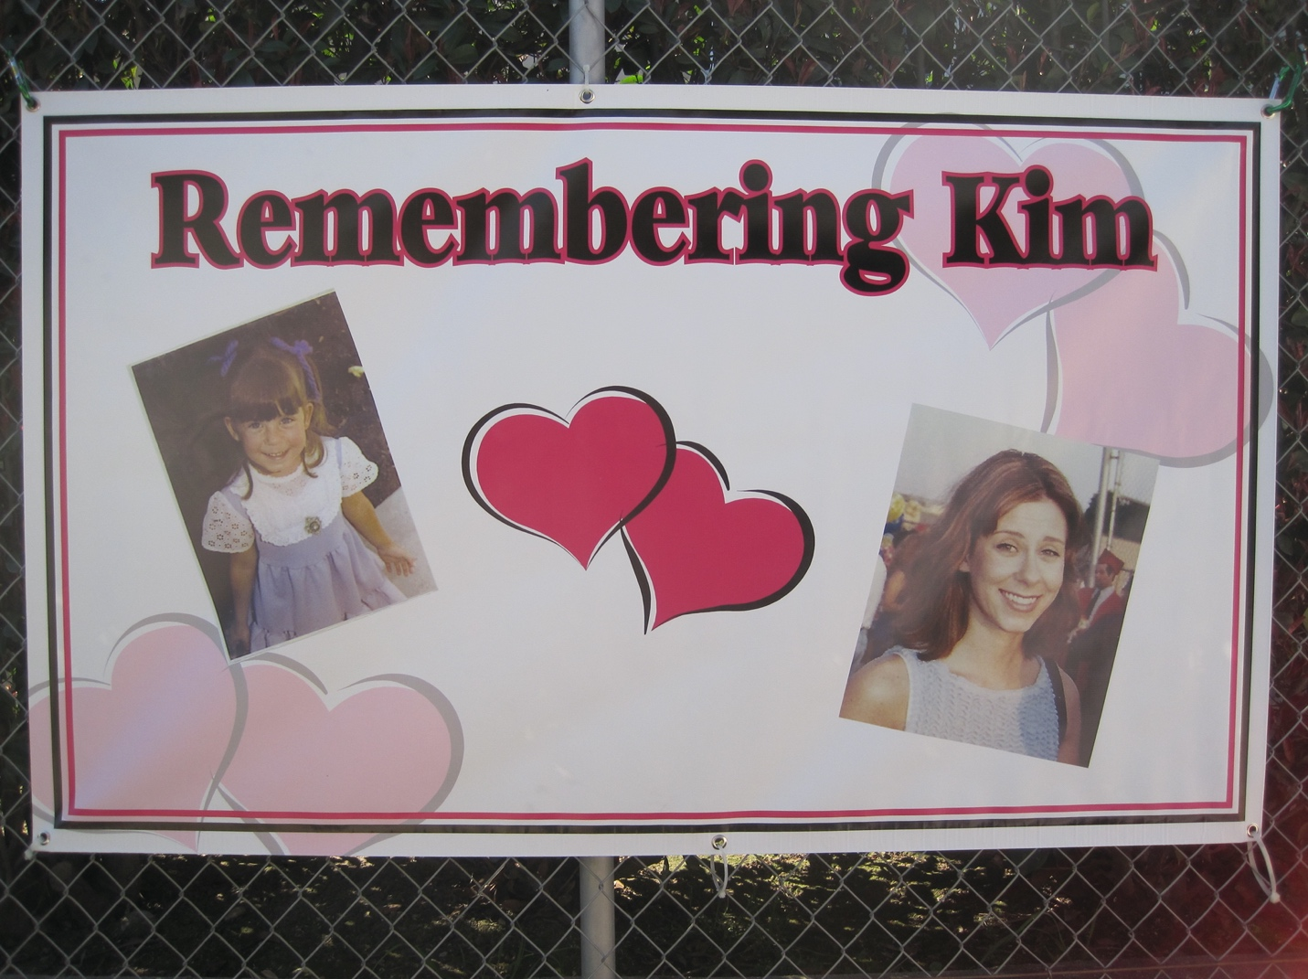

Graduation day 2002 was a beautiful sunny day filled with happiness and joy for every graduate and their proud parents. On that day as each graduate walked toward the podium to have their name read and receive the diploma they had worked so hard to obtain, their futures all seemed so bright.

Fast forward 10 years and you would expect that many of the class of 2002 would have gone on to earn their Masters and even a Doctorate in their chosen field, had started a career, fallen in love, married and even started a family. Unfortunately for Kim Holloway her plans to graduate and the dreams of all that normally followed came to a tragic end on March 2, 2002 when she died at age 27, just two months from graduating. Her unexpected death from a common medical condition that was misdiagnosed devastated her family and friends.

Her 10 year anniversary was marked by a different type of celebration, one celebrating Kim’s life. Friends and family gathered at the Holloway home in La Puente for an afternoon to remember their daughter, sister and friend Kimberly Anne Holloway. The remnants of her life were displayed throughout the house for all to see. Videos played on the TV and guests shared stories and remembrances of happier times. Her school work, music and sports awards were all that physically remained of this bright, energetic young woman who loved life.

Aside from the physical remnants and loving memories of a life that ended too soon there was one other thing Kim left behind. The money she had saved while working was used to fund a scholarship in her name to help other English Department students fulfill their dreams.

Kim, the oldest of four Holloway children was an honor student at William Workman High School in Industry where she ran track and participated in the Mt. SAC Relays, the Jesse Owens Games and CIF Track Finals. After high school she attended Mt. San Antonio College and worked at Disneyland. After graduation she worked fulltime for Disney as a restaurant scheduler. A few years later she returned to Cal State Fullerton to study English, a subject she dearly loved. Her younger brother Chris, a Psychology major, was also on track to also graduate in 2002. He and Kim had a friendly competition as to who would graduate first.

